**To Supply Leftover Food To Poor**

**Category: Salesforce**

**Skills Required: Salesforce Developer**

1. Project Overview
   1. Project Objectives and Goals

Objective:

This project aims to develop a Salesforce-based application designed to manage and streamline the distribution of leftover food to underserved communities. The primary goal is to enhance the efficiency of food drop-offs, coordinate tasks, manage volunteers, and generate insightful reports.

1. Detailed Description of Implemented Features
   1. Custom Objects

**1. Drop-Off Point:**

**Purpose:**

The Drop-Off Point object captures essential details about locations where food is dropped off. This helps in tracking and managing food distribution points effectively.

**Fields:**

* + Drop-Off Point Name: A text field representing the name of the drop-off point.
  + Location Details: A text field for additional details about the drop-off point location.
  + Distance: A number field that the distance from the drop-off point to the delivery area.
  + Venue: A lookup relationship field linking to the Venue object to provide a connection between drop-off points and venues.

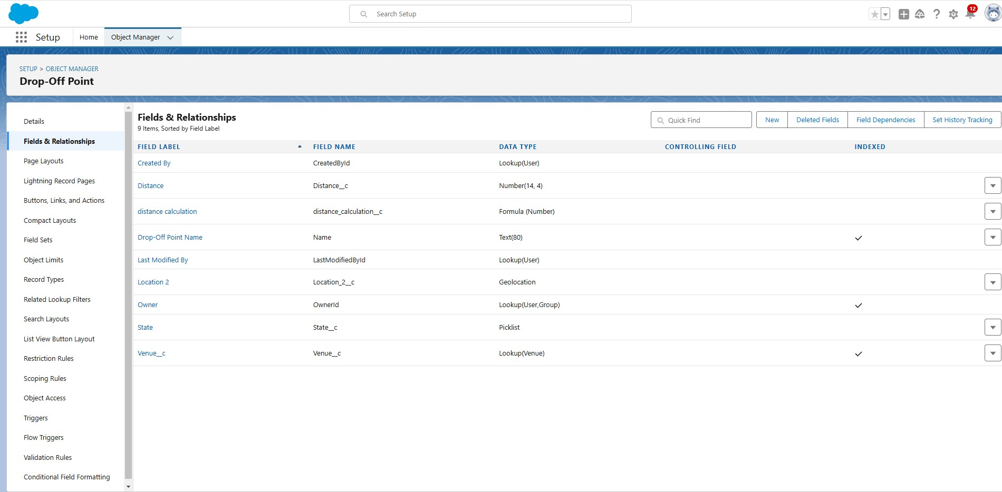

**Task :**

**Purpose :**

The task object is used to manage and track various tasks related to food distribution, including assigning tasks to volunteers and recording task details.

**Fields :**

* + Task name : A text field representing the name of the task.
  + Date : A date field indicating when the task is scheduled or completed.
  + Rating : A numeric field used to rate the task performance.
  + Drop-off point : A lookup relationship field liking to the drop-off point object to associate tasks with specific drop-off points.
  + Sponsored By : A lookup relationship field liking to the drop-off point object to indicate the sponsor of the task.

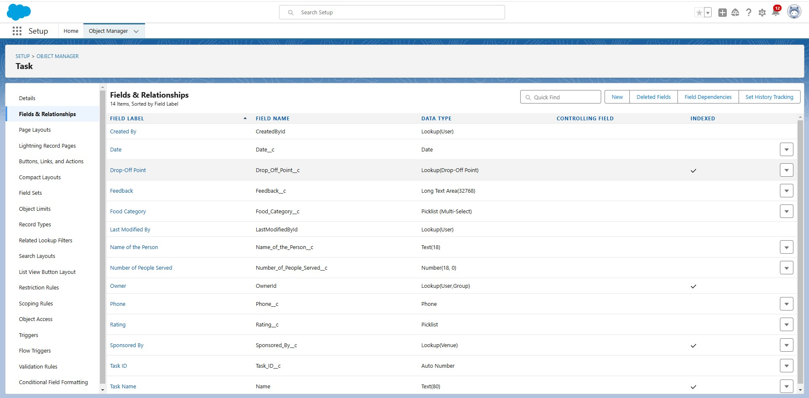

**Volunteer :**

**Purpose :**

The volunteer object tracks of individuals who are involved in the food distribution process, including their contact information and assigned tasks.

**Fields :**

* + Volunteer name : A text field for the name of the volunteer.
  + Contact email : An email field for the volunteer’s contact email.
  + Contact phone : A phone field for the volunteer’s contact number.
  + Assigned tasks : A related list showing tasks assigned to the volunteer.

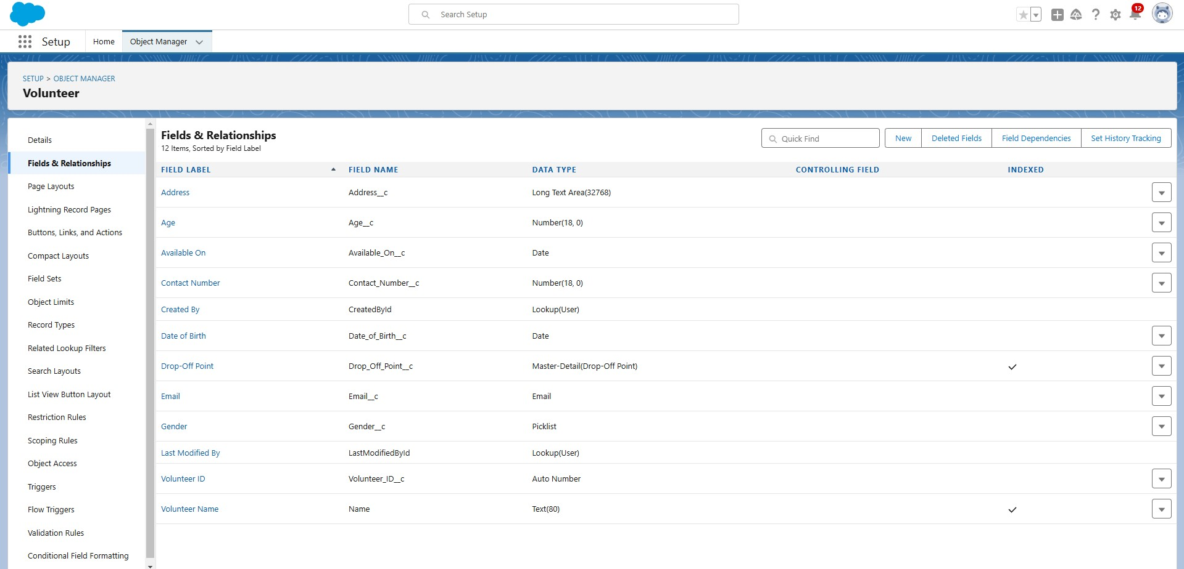

**Execution Detail :**

**Purpose :**

The execution detail object captures detailed information about food distribution activities,including which volunteers and tasks are associated with each distribution. **Fields :**

* + Execution detail name : A text field for naming the execution detail record.
  + Volunteer : A master-detail relationship field linking to the volunteer object to associate execution details with a specific volunteer.
  + Task : A master-detail relationship field linking to the task object to associate execution details with a specific task.
  + Details : A text field for additional information about the execution.

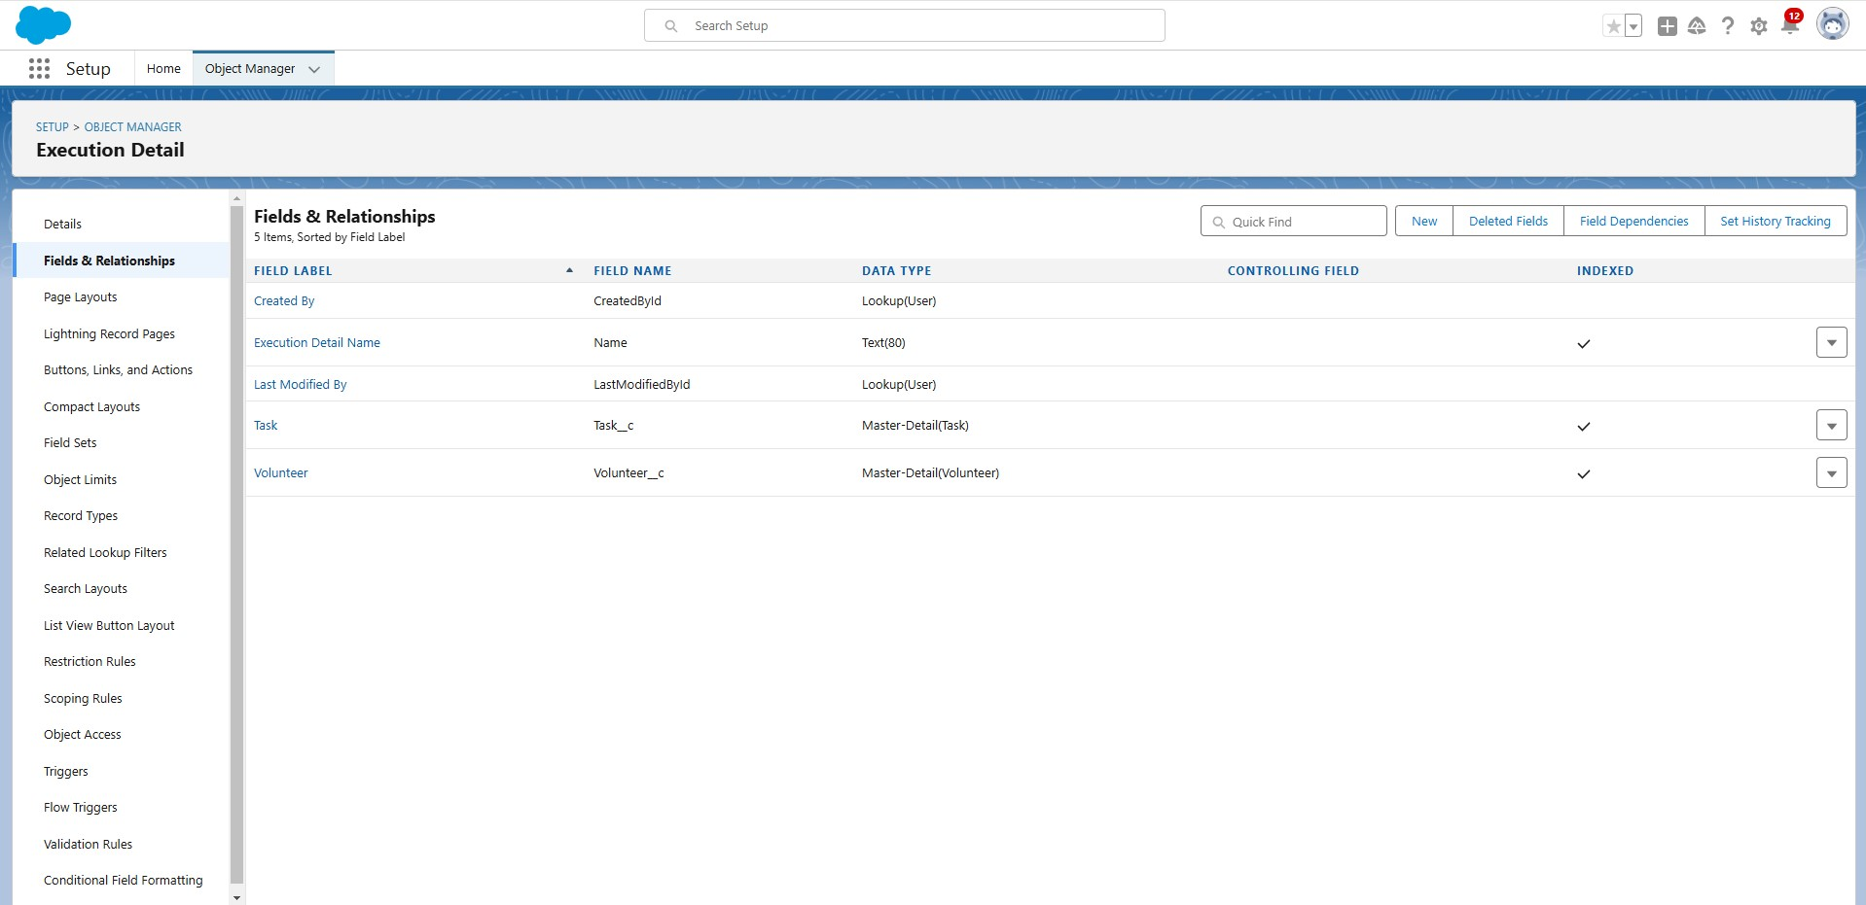

2.2 Object Relationships Master-Detail Relationships:

àExecution detail to volunteer : Ensures that each execution detail record is linked to a volunteer,making volunteer information essential for each distribution record. ➔ Execution detail to task : Ensures that each execution detail record is linked to a task,making task information essential for each distribution record.

* Task to Volunteer : Connects tasks to volunteers,enabling tracking of which volunteer is responsible for each task.
* Task to Drop-off point : Connects tasks to drop-off points,providing context on where each task is executed.
* Drop-off point to venue : Links drop-off points to venues,facilitating a detailed understanding of where food is being dropped off.

2.3 Sharing Rules

To ensure that records are shared appropriately based on distance criteria,the following sharing rules were set up :

1. Rule 1 :

○ Label : Rule 1

○ Criteria : Records where the distance is less than 15 kms.

○ Access : Shared with the public group – iksha

2. Rule 2 :

* + - Label : Rule 2
    - Criteria : Records where the distance is between 15 km and 30 km.
    - Access : Shared with the public group – NSS

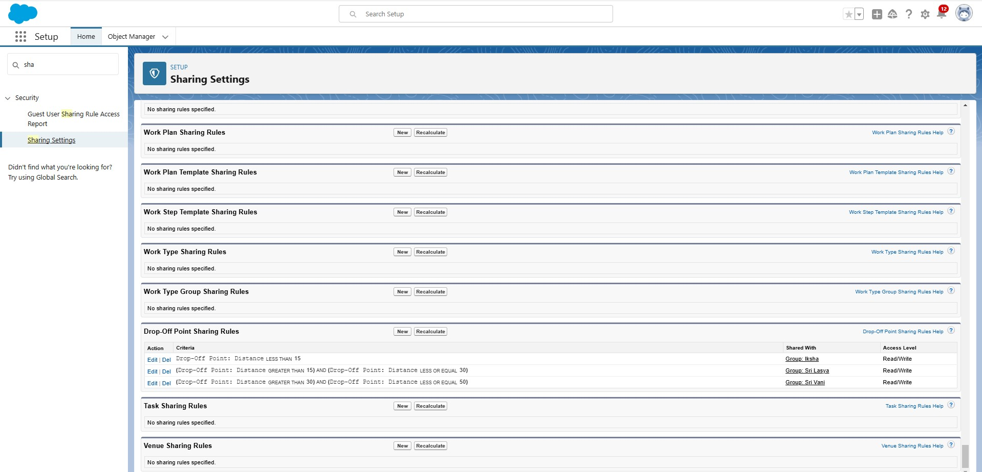

2.4 Flow and Dashboard

Flow : Venue flow

* Purpose : To manage and capture detailed information related to food drop-off points.
* Components :
  + Text component : For entering the venue name.
  + Email component : For entering the contact email of the venue.
  + Phone component : For entering the contact phone number of the venue.
  + Text component : For entering the venue location.
  + Number components : For entering latitude and longitude values of the venue.

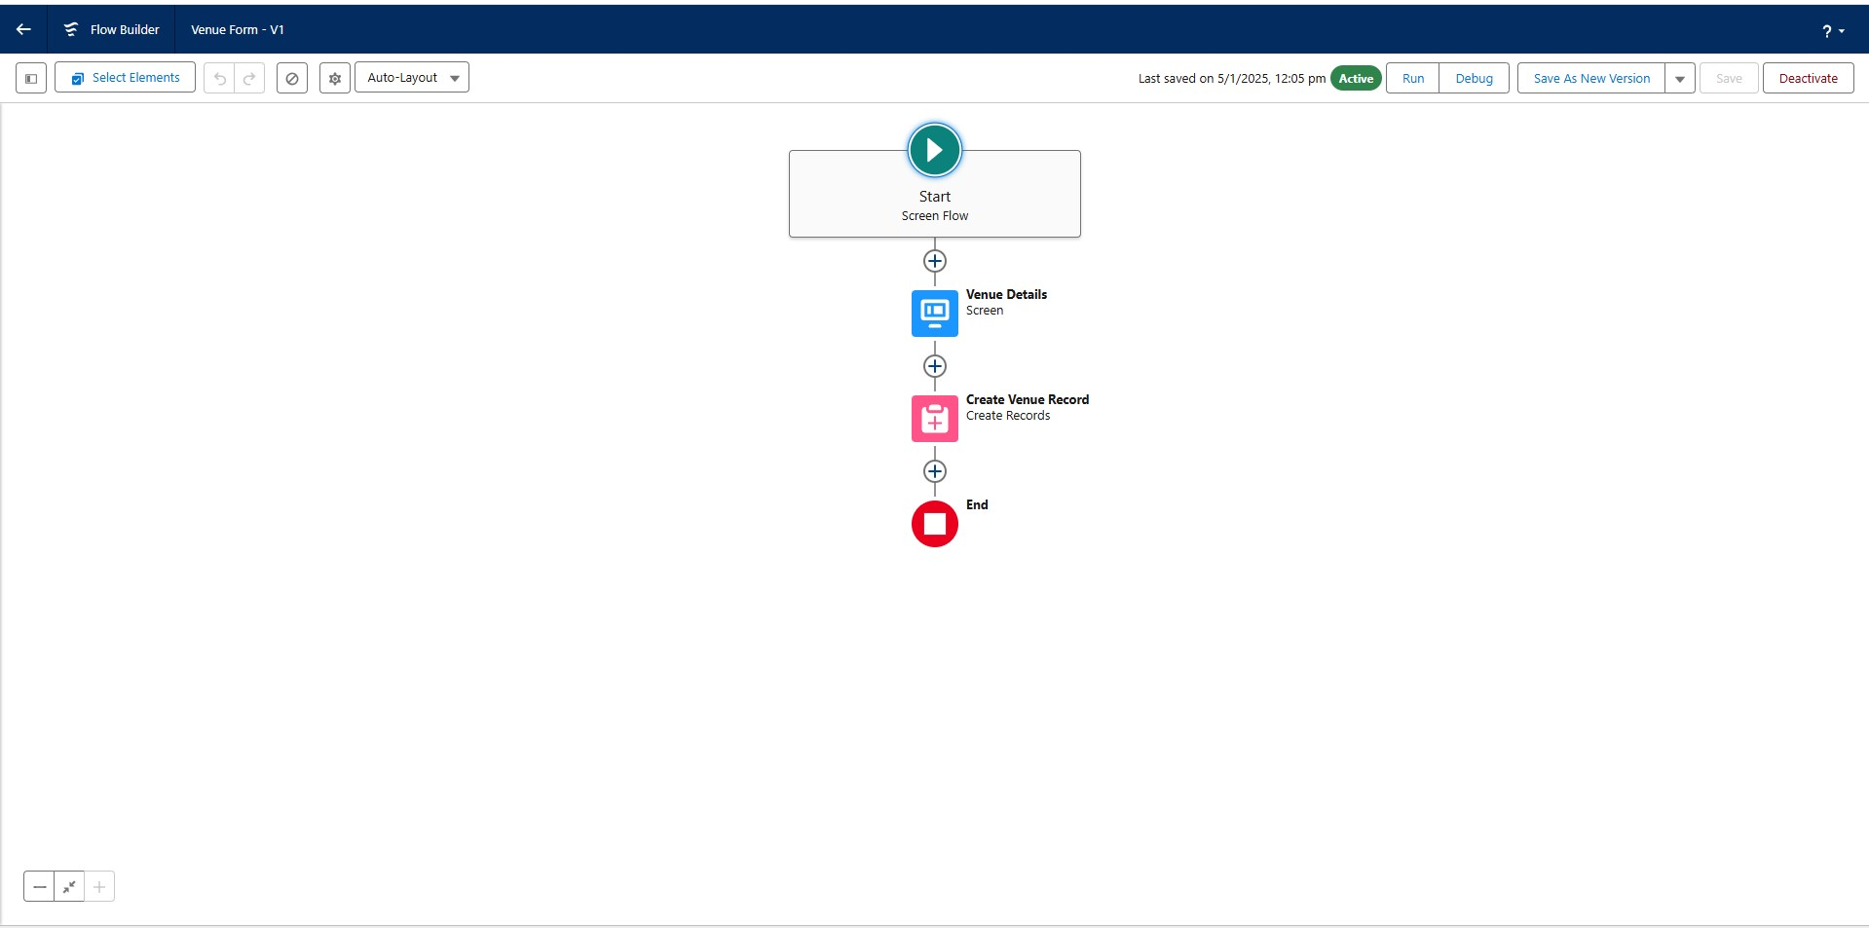

Dashboard :

* Name : Task Execution details
* Components :
  + Lightning Table : Displays detailed information about venues and

drop-off points,facilitating a comprehensive view of the data.

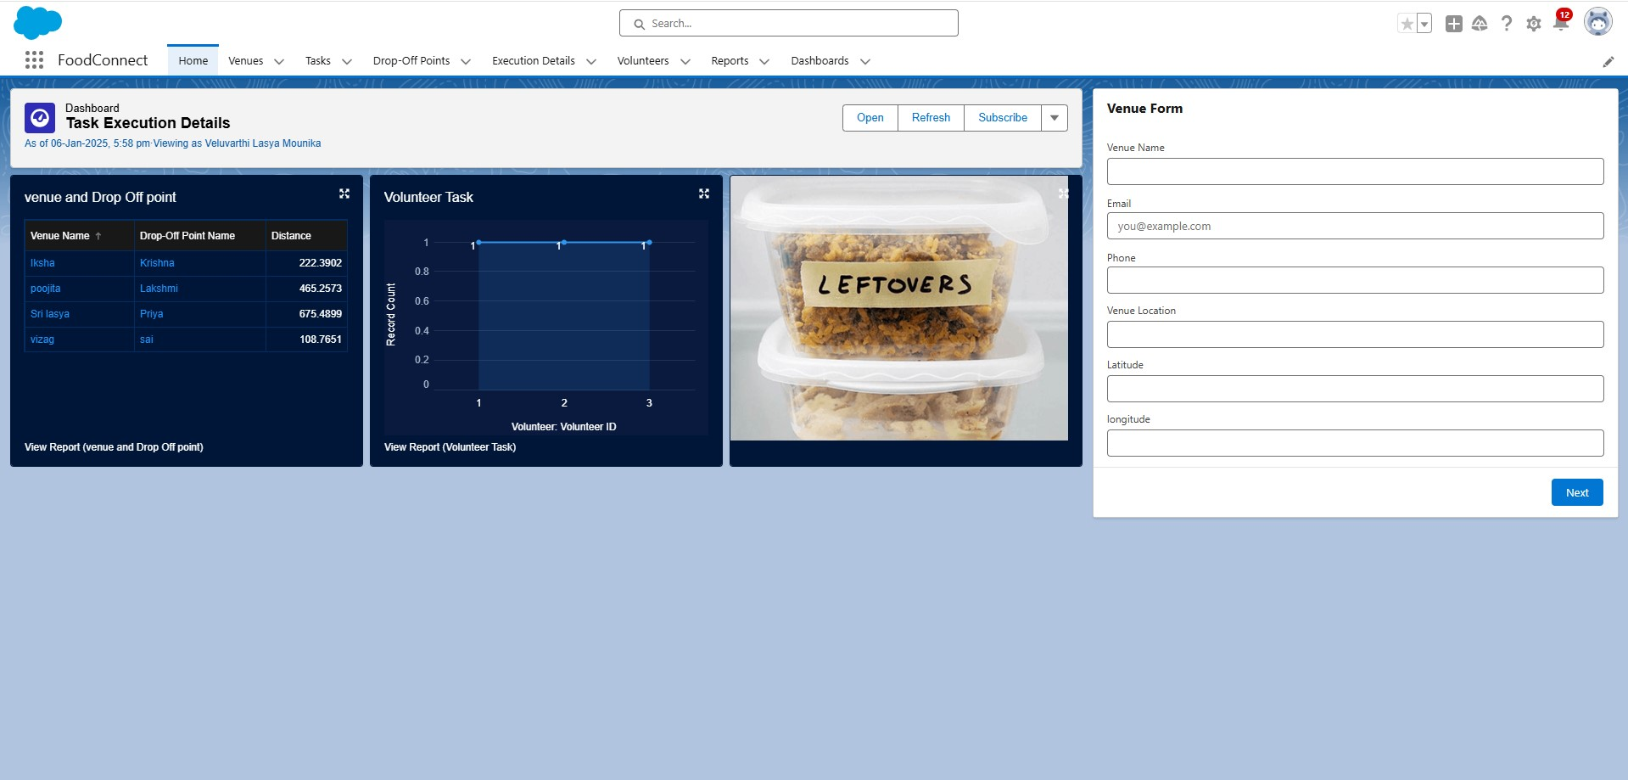

1. Configuration and Setup Instructions

3.1 Creating Custom Objects

1. Drop-off point :

* Navigate to Object manager > Create > Custom object .
* Enter details such as the label name,record name and other settings for drop off point.

2. Task :

* Navigate to Object Manager > Create > Custom Object.
* Enter details such as the label name,record name and other settings for

Task.

3. Volunteer :

* Navigate to Object manager > Create > Custom object .
* Enter details such as the label name,record name and other settings for

Volunteer.

4. Execution Detail :

* Navigate to Object manager > Create > Custom object .
* Enter details such as the label name,record name and other settings for

Execution Detail.

3.2 Sharing Rules Setup

* Go to sharing settings.
* Define new sharing rules for drop-off point based on distance criteria,ensuring appropriate access for different public groups.

3.3 Sharing Rules Set up

* Go to Sharing settings
* Define new sharing rules for drop-off point based on distance criteria ensuring appropriate access for different public groups.

3.3 Lightning App Builder

1. Create Home Page :

* Go to Lightning App Builder > New
* Select Home Page and name it “HOME Page”
* Add flow component to the page.

2. Save and Activate :

* Click on Save and Activation.
* Set the page as the default for the FoodConnect app.

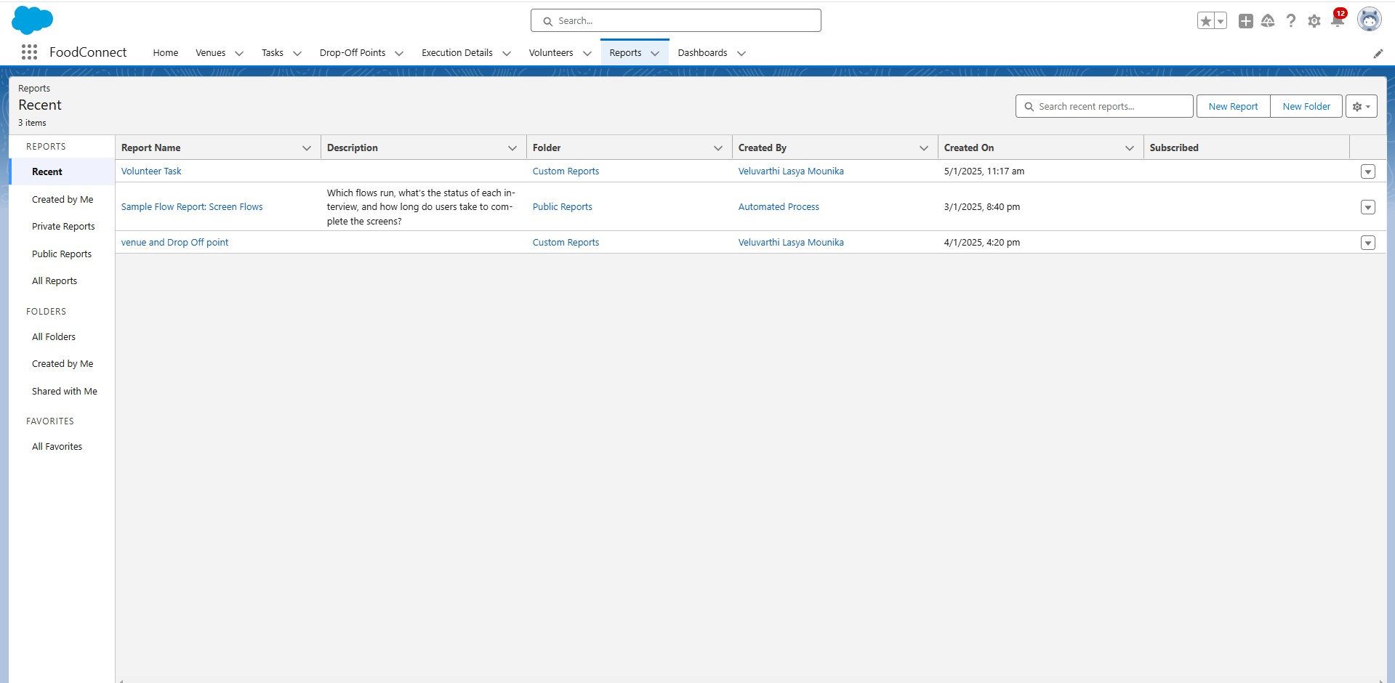

3.4 Report Types and Dashboards

1. Custom Report Types :
   * Create report types for venue with Drop-off with Volunteer and Volunteers with Execution Details and Tasks.

1. Reports :
   * Generate and configure reports using the custom report types to track and analyse relevant data.

1. Dashboards :
   * Configure dashboards to visualise data from reports and other components,providing insights into the overall distribution process.

1. Deliverables :
   * Code Files : Include Apex triggers and any other code implemented.
   * Output Screenshots : Provide Screenshots of custom objects,flows,dashboards and reports to illustrate the setup.
   * Project Documentation : Detailed descriptions of implemented features and set up

instructions.

* + Project Demonstration Video : A video showcasing the functionality of the application including key features and processes.